🔥 ListIterator (Very Simple + Complete Explanation)
✅ What is ListIterator?
👉 ListIterator is a cursor used to traverse elements one by one from a collection.
👉 It is a special cursor only for List
- Works with: ArrayList, LinkedList, Vector
- ❌ Not for Set, Queue, Map
👉 It is a bi-directional cursor
- ✔ Forward →
- ✔ Backward ←
👉 It was introduced in JDK 1.2

🔥 What extra power it gives?
👉 Compared to Iterator:
- ✔ Move forward → next()
- ✔ Move backward ← previous()
- ✔ Add elements
- ✔ Replace elements
- ✔ Remove elements

✅ Code Example
import java.util.*;
LinkedList<String> list = new LinkedList<>();
list.add("A");
list.add("B");
list.add("C");
ListIterator<String> it = list.listIterator();

🔍 Step 1: What is happening here?
ListIterator<String> it = list.listIterator();
👉 You are saying:
"Give me a special iterator that can move forward and backward in this list"
👉 listIterator() method is available only in List implementations

🔍 Step 2: Forward Traversal
while(it.hasNext()) {
System.out.println(it.next());
}
Methods used:
- hasNext() → check next element
- next() → move forward
- nextIndex() → gives next index

🔍 Step 3: Backward Traversal
ListIterator<String> it2 = list.listIterator(list.size());
while(it2.hasPrevious()) {
System.out.println(it2.previous());
}
Methods used:
- hasPrevious() → check previous element
- previous() → move backward
- previousIndex() → gives previous index

💡 Example Execution
List = [A, B, C]
Forward:
- A → B → C
Backward:
- C → B → A

🔧 Modification Operations (Power Feature)
while(it.hasNext()) {
String val = it.next();
if(val.equals("B")) {
it.remove(); // remove
it.add("X"); // add
it.set("Y"); // replace
}
}
👉 Supports:
- ✔ remove() → delete
- ✔ add() → insert
- ✔ set() → replace

🚫 Limitation
👉 ❌ Not a universal cursor
➡️ Works only with List

🔥 Iterator vs ListIterator vs Enumeration (Simple Comparison)
Feature | Enumeration | Iterator | ListIterator
Works with | Legacy classes | All collections | Only List
Direction | Forward only | Forward only | Forward + Backward
Read | ✔ | ✔ | ✔
Remove | ❌ | ✔ | ✔
Add | ❌ | ❌ | ✔
Replace | ❌ | ❌ | ✔

🔥 Real-Time Usage in Industry (Very Important)
✅ 1. for-each (MOST USED)
👉 Use when:
- Only reading data
- No modification
✔ Simple
✔ Clean
✔ Preferred

✅ 2. Iterator (SECOND MOST USED)
👉 Use when:
- Removing elements
- Need control
✔ Safe removal
✔ Controlled looping

❌ 3. ListIterator (RARELY USED)
👉 Use when:
- Need backward traversal
- Need add/replace while iterating

💡 FINAL MEMORY TRICK
👉 for-each → simple
👉 Iterator → control
👉 ListIterator → forward + backward + modify

📊 COMPLETE COLLECTION SUPPORT TABLE
Interface / Class | for-each | Iterator | ListIterator | Notes
Iterable | ✔ | ✔ | ❌ | Root for looping
Collection | ✔ | ✔ | ❌ | Base interface
List | ✔ | ✔ | ✔ | Only List supports ListIterator
ArrayList | ✔ | ✔ | ✔ | Most used
LinkedList | ✔ | ✔ | ✔ | Also supports Deque
Vector | ✔ | ✔ | ✔ | Legacy
Stack | ✔ | ✔ | ✔ | Legacy (avoid)
Set | ✔ | ✔ | ❌ | No index
HashSet | ✔ | ✔ | ❌ | Most used
LinkedHashSet | ✔ | ✔ | ❌ | Maintains order
TreeSet | ✔ | ✔ | ❌ | Sorted
Queue | ✔ | ✔ | ❌ | FIFO
PriorityQueue | ✔ | ✔ | ❌ | Heap-based
Deque | ✔ | ✔ | ❌ | Stack + Queue
ArrayDeque | ✔ | ✔ | ❌ | Most preferred
Map | ❌ | ❌ | ❌ | Not directly iterable

Eg: LinkedList_Eg5

Stack:
========
✅ What is Stack in Java?
👉 Stack is a class in Java that works on LIFO principle
(LIFO = Last In First Out)
📌 Example:
- You put plates one over another
- The last plate you put → comes out first

📦 Definition (Refined Version)
- Stack is a child class of Vector present in java.util package
- Syntax:
public class Stack extends Vector { }
- Introduced in JDK 1.0
- It is considered a legacy class
⚠️ What does "Legacy Class" really mean?
👉 Legacy class means:
- Old class (from early Java versions)
- Still exists, but not recommended for modern use
- Better alternatives are available

🔥 Why Stack is considered legacy?
Because it has problems:
- It extends Vector → which is synchronized (slow)
- Performance is not optimal
- Not flexible compared to newer collections

🚀 Modern Replacement (VERY IMPORTANT for interviews)
Instead of Stack, industry uses:
👉 Deque (ArrayDeque)
Example:
Deque<Integer> stack = new ArrayDeque<>();
stack.push(10);
stack.push(20);
System.out.println(stack.pop());

📊 Comparison (Interview Gold Point)
Feature | Stack (Old) | Deque (Modern)
Performance | Slow | Fast ⚡
Thread-safe | Yes | No (but faster)
Recommended | ❌ No | ✅ Yes

🎯 Important Interview Line
👉 If interviewer asks:
“Is Stack used in real-time projects?”
✔️ Best answer:
"Stack class is rarely used. Instead, we use Deque (ArrayDeque) for stack operations due to better performance."

Properties of Stack :-
- Stack follows the Last In First Out (LIFO) principle for inserting and removing elements.
- Stack can be implemented using Array, ArrayList, LinkedList, or Vector.
- Stack is an index-based data structure.

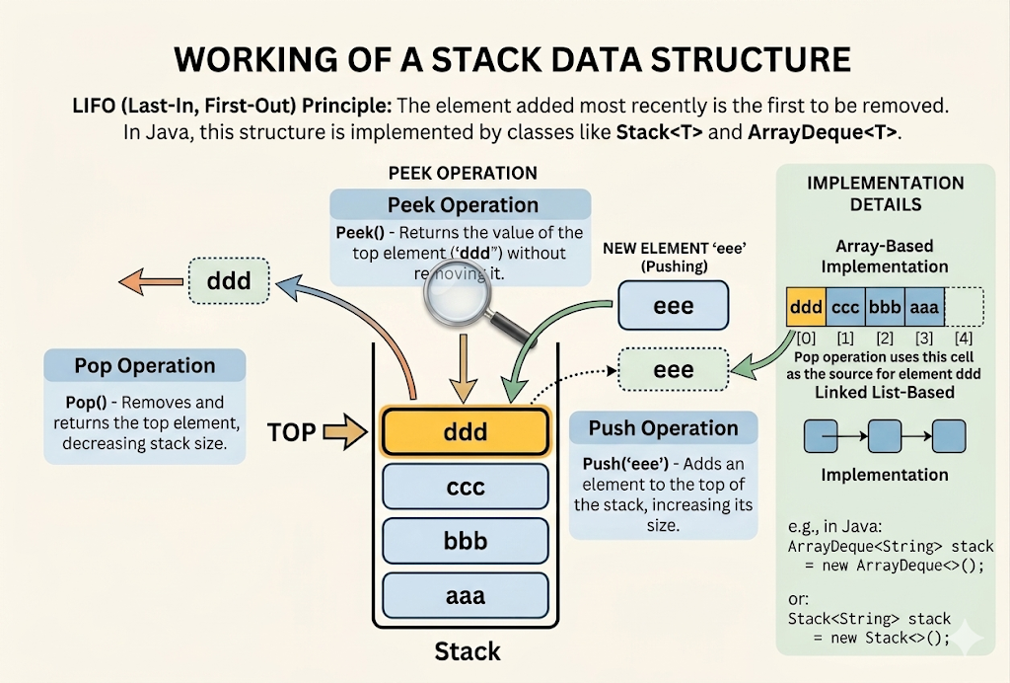

It extends Vector, so it gets many methods from:
- Vector
- List
- Collection

🧱 Constructors of Stack
✔ Correct:
public Stack()
👉 This creates an empty stack
Example:
Stack<Integer> stack = new Stack<>();
👉 Now stack is empty:
[]

⚙️ Methods of Stack (Simple Explanation)

1️⃣ push()
public Object push(Object obj)
👉 Adds element to top of stack
Example:
stack.push(10);
stack.push(20);
📦 Stack becomes:
[10, 20]
↑ top

2️⃣ pop()
public synchronized Object pop()
👉 Removes and returns top element
Example:
System.out.println(stack.pop());
📤 Output:
20
📦 Stack now:
[10]

3️⃣ peek()
public synchronized Object peek()
👉 Returns top element without removing
Example:
System.out.println(stack.peek());
📤 Output:
10
📦 Stack still:
[10]

4️⃣ search()
public synchronized int search(Object obj)
👉 Returns position from top (1-based index)
Example:
stack.push(30);
stack.push(40);
System.out.println(stack.search(30));
📦 Stack:
[10, 30, 40]
📤 Output:
2 (because 30 is 2nd from top)
👉 If not found → returns -1

5️⃣ empty()
public boolean empty()
👉 Checks if stack is empty
Example:
System.out.println(stack.empty());
📤 Output:
false

Eg: Stack

🔥 Queue (Very Simple + Complete Explanation)
✅ What is Queue?
👉 Queue is an interface in Java.
👉 It is a child interface of Collection
👉 Syntax:
public interface Queue<E> extends Collection<E> { }
👉 It was introduced in JDK 1.5

🔁 How Queue works?
👉 Queue follows:
👉 FIFO (First In First Out)
💡 Meaning:
- First element added → first element removed

💡 Example (Real-Life Analogy)
👉 Think of a queue at a bus stop 🚍
- Person who comes first → goes first
- Person who comes last → goes last
✔ Same concept in Java Queue

🔧 Basic Operations
Operation | Method | Meaning
Add element | offer() | Insert element
Remove element | poll() | Remove and return
View element | peek() | See without removing

🔍 Example Code
import java.util.*;
Queue<String> queue = new LinkedList<>();
queue.offer("A");
queue.offer("B");
queue.offer("C");
System.out.println(queue); // [A, B, C]
System.out.println(queue.poll()); // A
System.out.println(queue.peek()); // B

🔄 Output Flow
Queue = [A, B, C]
- poll() → removes A
- Remaining → [B, C]
- peek() → shows B

🔥 Important Point
👉 Default Queue follows FIFO
👉 But some implementations change behavior:
- PriorityQueue → based on priority (not FIFO)
- Deque → can act as queue + stack

🧠 Common Implementations
- LinkedList
- PriorityQueue
- ArrayDeque

🚫 Note
👉 Queue is an interface
➡️ We cannot create object directly
✔ We use implementation classes:
Queue<Integer> q = new LinkedList<>();

🧠 Final One-Line Definition (Interview)
👉 Queue is a Collection interface that follows FIFO order and is used to process elements in sequence.

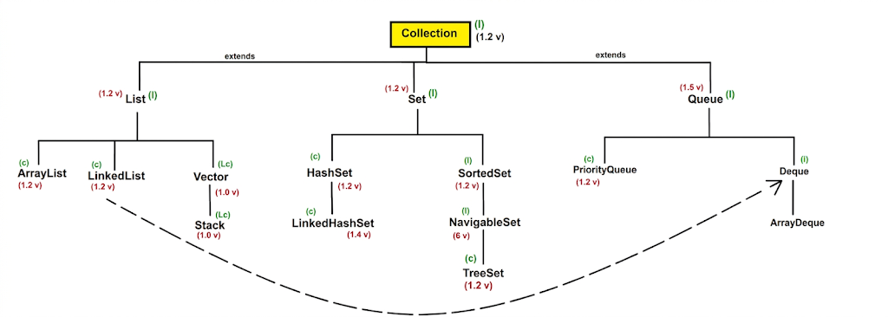

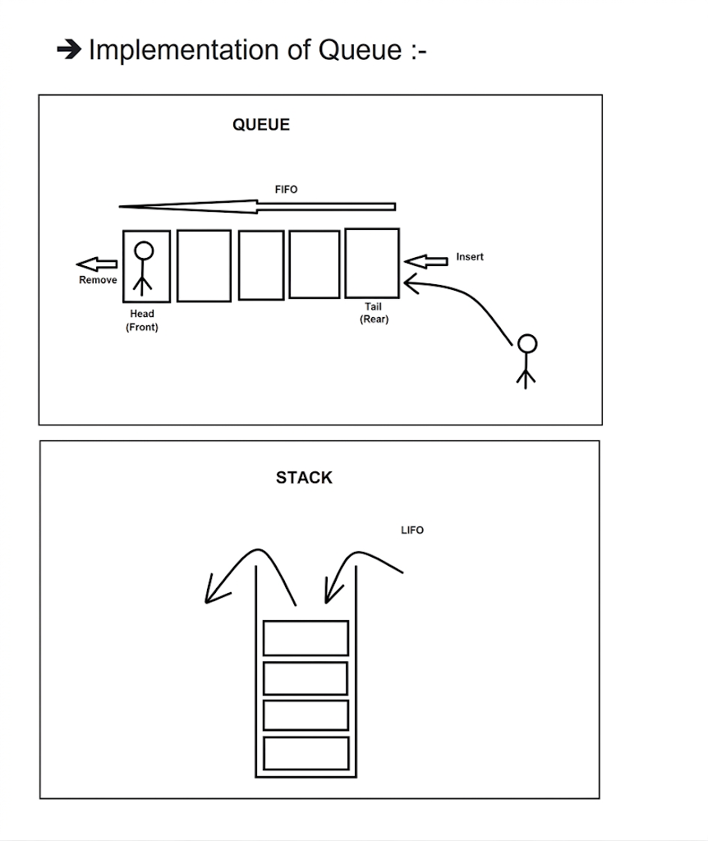

🔥 Queue – Properties (Final Version)
✅ Properties of Queue
- 👉 Queue generally follows FIFO order (First In First Out)
✔ First inserted → first removed
- 👉 Some implementations may change ordering behavior
  - Example: PriorityQueue → follows priority (not FIFO)
- 👉 Queue stores elements based on how it is declared:
  - ✔ With generics → stores homogeneous elements (same type)
Queue<String> q = new LinkedList<>();
  - ⚠ Without generics → can store heterogeneous elements (different types)
Queue q = new LinkedList();
  - ❗ But this is not recommended due to runtime errors like ClassCastException
- 👉 Queue allows duplicate elements ✔
- 👉 Null handling depends on implementation:
  - PriorityQueue ❌ does NOT allow null
  - LinkedList ✔ allows null (but usually avoided in real projects)

